Biochemistry I Kinetic Homework ________________________________

- (20 points) Consider the following plot of initial velocity of a reaction versus substrate concentration:

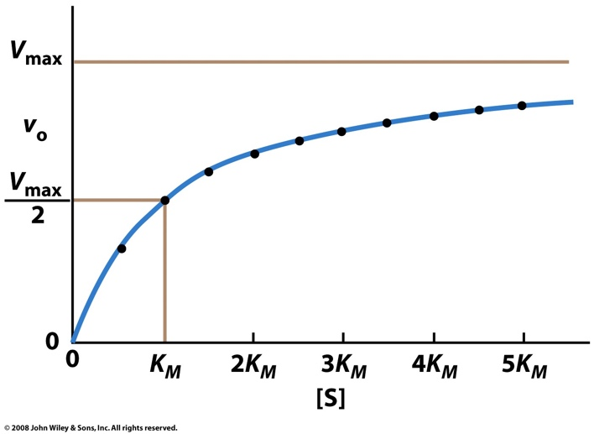
- Describe the meaning of K_{M} in words. Using the Michaelis-Menten equation, show mathematically how K_{M} values change v₀ (i.e. how does a small or large K_{M} value change v₀).

- Using the Michaelis-Menten equation, show mathematically why at low substrate concentrations v₀ is very small.

- Using the Michaelis-Menten equation, show mathematically why v₀ = V_{max} when K_{M} = [S]

- Using the Michaelis-Menten equation, show mathematically why at high substrate concentrations, v₀ ≈ V_{max}.

- At high [S], k₂ becomes the rate limiting step of the reaction. Knowing this information, mathematically explain how K_{M} ≈ K_{S}.

- Using the Michaelis-Menten equation, explain why it would be good to have a very small K_{M} (K_{S}) value.

Applications of Enzyme Kinetics:

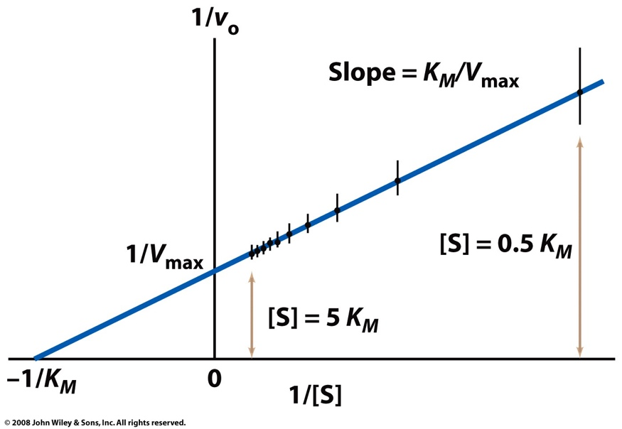
- (10 points) Consider the following variation of the Michaelis-Menten equation, and the corresponding Lineweaver-Burk plot of 1/v₀ versus 1/[S]:

- What does the x-intercept give you?

- What does the y-intercept give you?

- Why does the data tend to cluster on the left hand side of the graph?

- What is the propensity for error on the right side of the plot and what significance does that have?

- Why is this type of a plot useful experimentally?

Applications of Enzyme Kinetics:

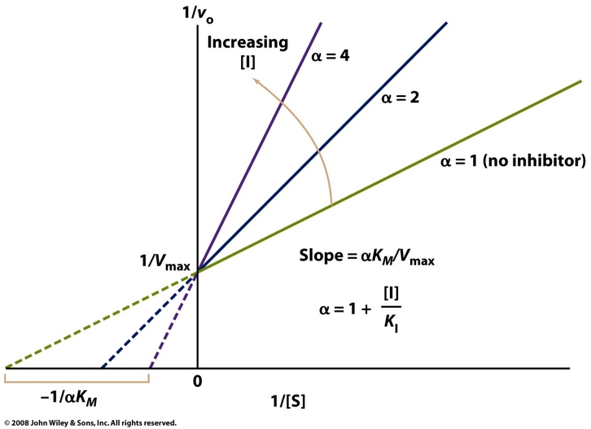
- (20 points) Consider the following Lineweaver-Burk plot of 1/v₀ versus 1/[S]:

- What type of inhibition is this, and how can you tell?

- How does this mechanism of inhibition work? Be sure to address where the inhibitor binds, and how this affects the enzyme.

- Describe:
- in words what the parameter “α” is

- what its limits (i.e its maximum and minimum values) are

- how K_{I} can impact the magnitude of α

- what impact α has on the observed Linweaver-Burke plot.

- Describe what happens to the following terms with increasing [I]:

- K_{M}

- α

- V_{max}

- What is the capability of increasing [S] to overcome the inhibition?

